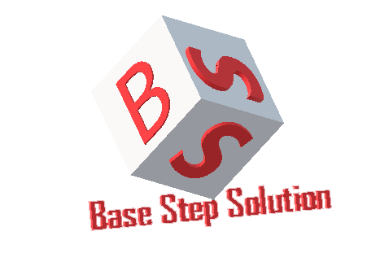

Vision and Scope

Văn Lang Admissions

# Revision Table

|  |  |  |  |
| --- | --- | --- | --- |
| Author | Date | Reason for changes | Version |
|  |  |  |  |
|  |  |  |  |
|  |  |  |  |
|  |  |  |  |
|  |  |  |  |

Table of Contents

Revision Table 1

1. INTRODUCTION 3

1.1. Purpose 3

1.2. Audience 3

2. Business Requirement 3

2.1. Background 3

2.2. Business Objective and Success Criteria 3

3. Vision of Solution 4

3.1. Vision Statement 4

3.2. Major Feature 4

4. Scope and Limitations 4

4.1. Scope of Initial Release 4

4.2. Scope Of Subsequent Release 4

4.3. Limitations and Exclusion 5

5. Business Context 5

5.1. Stakeholder Profile 5

5.2. Project Constraint 5

5.3. Operating Environment 6

# INTRODUCTION

## Purpose

## Audience

# Business Requirement

## Background

## Business Objective and Success Criteria

# Vision of Solution

## Vision Statement

## Major Feature

# Scope and Limitations

## Scope of Initial Release

## Scope Of Subsequent Release

## Limitations and Exclusion

# Business Context

## Stakeholder Profile

## Project Constraint

## Operating Environment

|  |  |  |  |  |
| --- | --- | --- | --- | --- |
| Item | Webserver (minimal) | Webserver (recommended) | Combined Web & Database Server (minimal) | Combined Web & Database Server (recommended) |
|  |  |  |  |  |
|  |  |  |  |  |
|  |  | | | |
|  |  | | | |